LED chaser

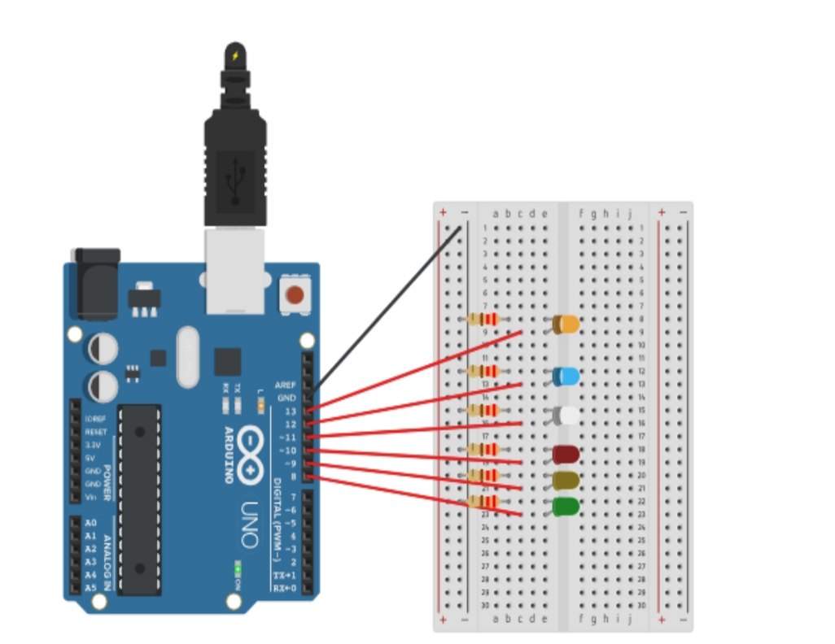

THEORY

Concept used:- by using for loop w are calling each led again and again in sequence.

Observation :- we have observe by using simple circuit we can make better lighting for household.

Problem and troubleshooting :- too many led was fuse before we use them so we check there continuity

Precaution :- LED get fuse if we supply more voltage through them. So apply resistor before led.